भारत सरकार/Government of India
परमाणु ऊर्जा विभाग /Department of Atomic Energy
राजा रामन्ना प्रगत प्रौद्योगिकी केंद्र /Raja Ramanna Centre for Advanced Technology
Technical Specification of Binary Gas Mixing Instrument (BGMI)
- Introduction
This specification is for supply of Binary Gas Mixing Instrument (BGMI) required for accurately mixing two gases (would refer as G1 & G2 further). The mixed gas composition will be used as shield gas during Gas Tungsten Arc Welding (GTAW). As this instrument is to be used as a mobile device, so a laptop PC is also required. An Indicative P&ID and CAD model of the Instrument are given in Fig: 1 and Fig: 2 respectively.

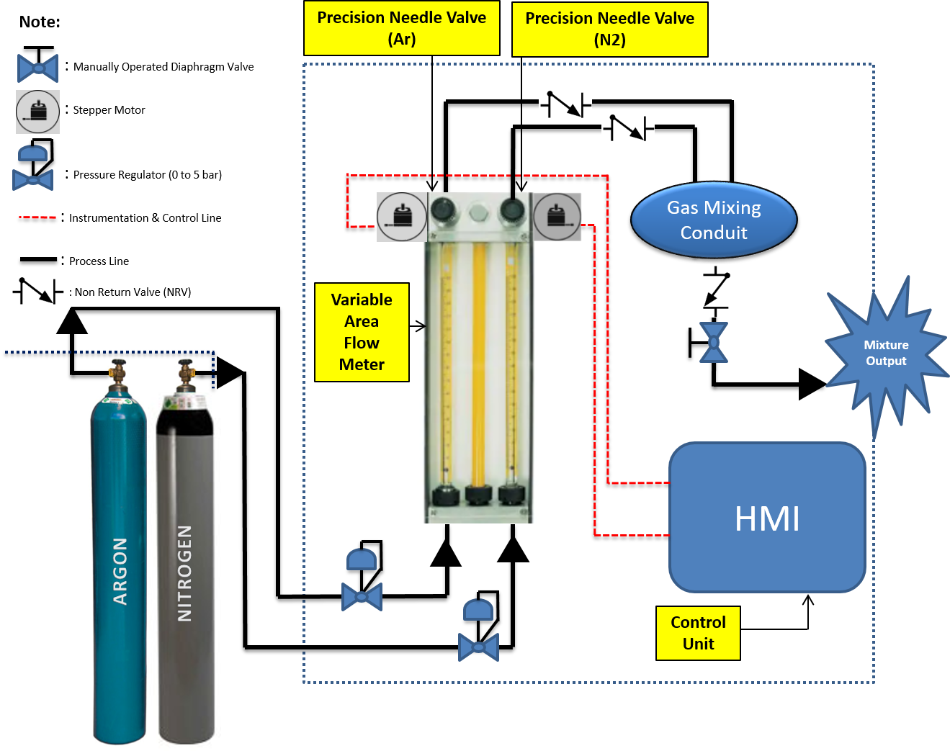
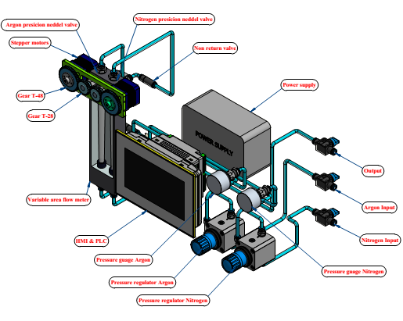

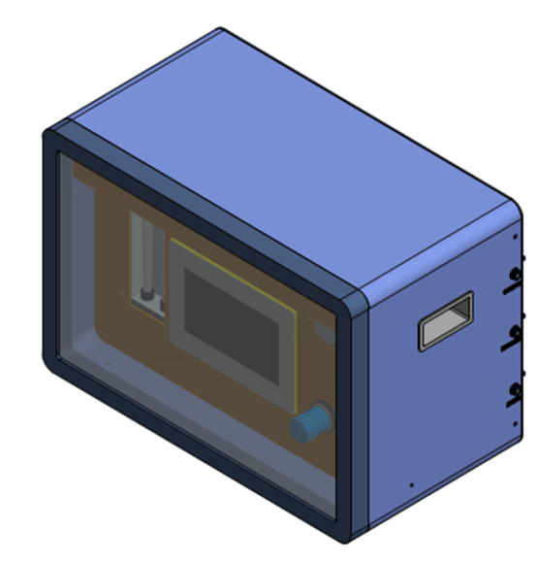

- Scope of supply scope of supply includes 01 No. of BGMI and 01 No. of dedicated laptop PC with control software and GUI installed as per technical specifications given in this document.

- Technical Specification for BGMI
S. No. | Parameters/Item | Specification |  | Offered Value/ Confirmation
 | Flow control mechanism. | Multi-tube Gas Proportioning Variable Area Flow Meters (MGVFM)
 | Input and Output | Two Input (G-1 & G-2), and One Output (Mixture Gas)
 | Gas - 1 | Nitrogen (N₂)/ Argon (Ar)/Helium(He)/Hydrogen(H₂₎/oxygen(O₂ )(any one)
 | Gas - 2 | N₂/ Ar/He/H₂/O₂ (any one)
 | Gas - 1 flow range of MGVFM. | Refer to table no. 1
 | Gas - 1 flow resolution of MGVFM. | ≤ ±2% of full scale(FS) at NTP.
 | Gas - 2 flow range of MGVFM. | Refer to table no. 1
 | Gas - 2 flow Resolution of MGVFM. | ≤ ±2% of FS at NTP.
 | Pressure Regulator & gauge at inlet of Gas-1 and Gas-2 (2 Nos.) | Up to 5 bar (gauge)
Multi Tube Gas Proportioning Variable Area Flow Meter
Suggested Model: FL-2GP-04C-41C of OMEGA® or Equivalent
Link: https://www.omega.com/en-us/flow-instruments/flow-meters/variable-area-flow-meters/p/FL1GP-8GP-Series
Note: The model suggested above is just to give an overview of flow values for individual gases. Purchaser do not endorse any particular make or model.
 | Flow Tube | 150 mm-Borosilicate glass
 | End Fittings | Black and anodized aluminium or 316 SS
 | Packing and O-Rings | Buna N
 | Accuracy: | ±2% FS
 | Repeatability: | ±0.25% FS
Table: 1 - Gas flow capacity ranges of flow tubes in MGVFM.
S. No. | Gas flow capacity range (cc/min.)
 | Ar | CO2 | He | H2 | N2 | O2
G1 | 0-12500  (± 5%) | 0-12500  (± 5%) | 0-34000  (± 5%) | 0-55000  (± 5%) | 0-15000  (± 5%) | 0-14000  (± 5%)
G2 | 0-600  (± 10%) | 0-700  (± 10%) | 0-1000  (± 10%) | 0-2000  (± 10%) | 0-750  (± 10%) | 0-700  (± 10%)

 | Precision Needle Valves | 16 turns for full scale.
3.10 | Stepper Motor with 1.8º step angle directly connected to the flow meter knob or by idler/gear to control flow through needle valves- 2 Nos.
3.11 | Manually operated Throttle Valves (4 Nos.) | To operate and isolate the Instrument (as specified in P&ID)
3.12 | Gas mixing conduit | Inline baffles for blending the gases.
3.13 | Pressure Regulator & Gauge | 0 to 10 bar (Gauge) with a resolution ≤ 0.1 bar
3.15 | Mixer output flow | 0-15000 cc/min. (refer table 1)
3.17 | Accuracy of mixture | ≤ +0.2% on the set value of nitrogen percentage. Explanation - If the set value for nitrogen is 2% then the actual percentage measured should be between 2% and 2.2%. Similarly, if the set value for nitrogen is 3% then the actual percentage measured should be between 3% and 3.2%.
3.19 | Display and Process Controller Features
3.19.1 | Display |  | - Easy to read display  - Self-illuminating
3.19.2 | Display Parameters |  | - G1  - G2  - Mixture flow rate.
3.19.5 | Control |  | Manipulation of needle valves with respect to percentages of G1 & G2 in mixture and flow at output.
3.19.6 | Inlet connection |  | Standard with push fit
3.19.7 | Outlet connection |  | Standard with push fit
3.19.8 | Gas fitting adapters |  | ¼” NPT male and female SS adapters at relevant places
3.19.9 | Instrument Cabinet |  | Full Instrument will be housed in powder coated MS cabinet with handles for mobility.
3.19.10 | Power Supply |  | Compatible with the Instrument (In case of batteries – it must be Rechargeable with charger Instrument)
3.19.11 | Protection |  | IP50 or better
3.20 | Graphic user interface functions
3.20.1 | Gas selectors |  | Two separate drop down menus for selection of gases for needle valve 1 & 2, Which in turn calls their flow values and incremental steps presets.
3.20.2 | Mixture values |  | An input for percentage of any one gas.
3.20.3 | Calibration menu |  | A separate calibration tab should be visible to calibrate the instrument for the stored values through connected laptop PC.
3.21 | Memory
3.21.1 | Flash memory |  | 512 MB or more to store the presets which can be called with one click.
3.21.2 | Rewriting of memory |  | The presets stored in the memory should be rewritable to change the preset values as & when required.
3.22 | Human machine interface (HMI)
 | HMI shall be equipped with all the features listed in 3.20 of this technical specifications. It shall have touch pad in it.

- Technical Specification for Laptop PC:
A dedicated laptop PC is to be supplied along with BGMI with the control software and GUI module preinstalled in it. The connectivity from the laptop to the instrument should be either USB or HDMI. The technical details are as follows;

S. No | Parameter | Description / Specification
 | Type | Thin and light laptop PC.
 | Processor | 11th Gen Intel Core i7-1165G7 processor or superior
 | Core | 4 or more
 | Memory | 16GB DDR4 3200 MHz, Upgradable upto 32GB.
 | Storage | 1TB 7200 RPM SSD hard disk.
 | Graphics | Intel Iris Xe Graphics or better.
 | Operating system | Windows 10 Professional 64 bit or latest.
 | Display | 14-inch (35.56 cm) screen with (1920X1080) Full HD TN Antiglare Display.
 | Mouse | USB 3-button optical scroll mouse, USB standard keyboard
 | Connectivity | Intel Wi-Fi 6 AX201, 802.11ax 2x2 Wi-Fi + Bluetooth 5.1
 | Power & Battery | 240 V, 50 Hz, Integrated Li-Polymer 45Wh battery, supporting Rapid Charge (charge up to 80% in 1hr) with 65W AC adapter | EPEAT Gold, ENERGY STAR 8.0 Rated
System I/O
 | USB | 2× USB2.0, 4× USB3.1 or better
 | Serial Port | 1x USB 2.0, 1x USB 3.2 Gen 1 (Always On), 1x Thunderbolt 4, USB4 40Gbps (support data transfer, Power Delivery 3.0 and DisplayPort 1.4), 1x HDMI 1.4b, 1x Ethernet (RJ-45), 1x Headphone, microphone combo jack (3.5mm).
 | Ethernet | 2× 10/100/1000 Mbps Ethernet or more
 | Video interface | 1× HDMI / 1× VGA or more
 | Audio | 1× Audio input / output or more

- Acceptance Criteria
S. No. | Item | Bidder’s confirmation
5.1 | Integration of Instrument at purchasers place.
5.2 | Instrument to be validated for its calibration using BGA for entire range of mixing with output flow variation.
5.3 | Mixing of 0.5 to 5% N₂ with a resolution of 0.2% (balance argon) to be demonstrated and proved at purchasers place.
5.4 | Mixing output 0-10 LPM (Step of 1 LPM) to be demonstrated and proved for 10 pre-set mixing ratios (i.e.: 0.5%-5.0 % N₂ balance argon with a step size of 0.5%).
- INSTALLATION, COMMISSIONING AND TRAINING
BGMI shall be installed at DMTD by the manufacturer within 15 days after delivery. A one day training shall be given to any one official from DMTD regarding the working of the instrument.
- PACKING AND TRANSPORT TO RRCAT
The BGMI shall be properly packed to protect it from physical damage and any possible deterioration in performance due to transport conditions.
- DELIVERY
The BGMI shall reach purchaser’s stores within 3 months of placement of purchase order.

End of Document

